|  |  |  |
| --- | --- | --- |
| CONOPS | February 16  2016 | |
|  | | Concept of Operation |

|  |  |  |  |
| --- | --- | --- | --- |
| **Revision record** | | | |
| Version | Date | Attendees | Comment |
| 1.0.0 | 16.02.16 | Arshad Shakil,  Badis Madani,  [Håkon Hedlund](https://www.facebook.com/hakon.hedlund)**,**  Zhili Shao |  |
| 2.0.0 | 29.03.16 | Arshad Shakil,  Badis Madani,  [Håkon Hedlund](https://www.facebook.com/hakon.hedlund)**,**  Zhili Shao | Rewrite CONOPS according to IEEE standard. |

Contents

1. Scope 3

2. Current system or situation 3

3. Changes to current situation 3

3.1 Justification of Changes 3

3.2 Proposed System Attributes 5

3.3 Description of Desired Changes 5

3.4 Changes Considered But Not Included 6

3.5 Constraints 6

4. Concepts for the proposed system 7

5. Operational scenarios 8

6. Analysis of the proposed system 8

6.1 Improvements 8

6.2 Disadvantages 8

# Scope

This Concept of Operations (Conops) document describes the current HVAC control systems and the desired characteristics of it from the user’s viewpoint along with a justification for changes to it as well as the proposed control systems and an operational analysis.

# Current system or situation

Several HVAC control systems were inspected and the DDC (direct digital control) was found as the most common deployed control system today.

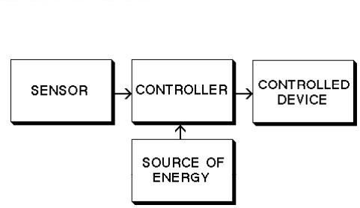

Figure 1: Basic Control System

HSN Krona building was inspected as an example of a facility is where it was found through the conducted survey that classrooms users are not able to change their indoor environment parameters (temperature, humidity nor air quality) but in the offices the employees can regulate their office’s temperature only from the heater available in their working place.

# Changes to current situation

## 3.1 Justification of Changes

According to our survey about indoor environment (Table 3.1) in Krona (Southeast University College of Norway, Kongsberg campus), people who are satisfied with their indoor temperature, humidity and air quality occupy 46.67%, 47.46%, 38.98% respectively. There are still more than 18% people unhappy about their indoor environment, especially the air quality.

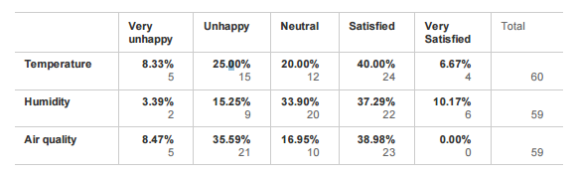

Table 3.1.1 Indoor environment perimeters

That means the HVAC system does not satisfy user’s requirement in this building, When be asked whether they want regulate the indoor environment by themselves, most of them have this requirement. From 3.1.1, we can see that people are urgent to control indoor temperature by themselves, air quality is also very important for users.

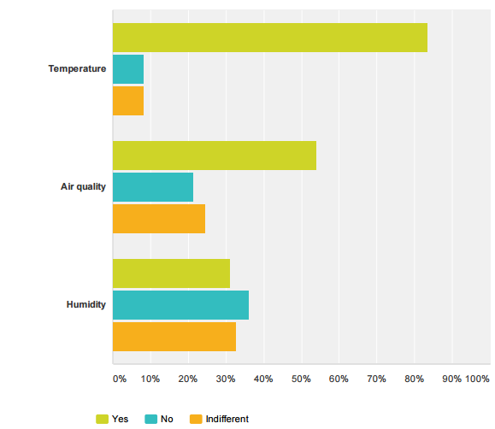

Figure 3.1.1 Indoor environment perimeters control

Table 3.1.2 show the statistics about control methods of HVAC system, People prefer to use panel and mobile phone to access their indoor environment control.

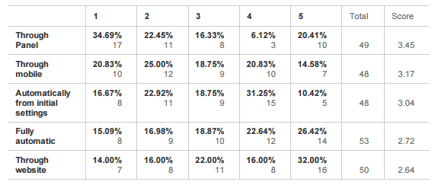Table 3.1.2 Control methods

The analysis of survey from users shows a new HVAC control system is needed. People need to use this system to regulate their indoor environment.

## 3.2 Proposed System Attributes

From an overall system perspective, the proposed HVAC control system should possess the following attributes.

• Initial cost - Cost of implementation and deployment of the solution

• Stability - The time of the solution can work without problems happen

• Efficiency - Is the solution energy saving or not

• Compatibility – The solution can work with HVAC system well or not

• Easiness of use - Is solution user friendly for all possible users

## 3.3 Description of Desired Changes

As previously survey showed, the HVAC control system cannot satisfy users’ requirement. There is no existing control system that adequately meets the needs of users. But the existed Direct Digital Control (DDC) system which is the most common deployed control system today, can make some changes to meets users’ requirement. Here are the items needs to be changed on existing HVAC control system.

• Indoor environment parameters

• Control methods

• Energy saving

## 3.4 Changes Considered But Not Included

There are no changes to the proposed HVAC control system that were considered but not included in the proposed list of HVAC control system attributes. Changes to the items provided in those sections will not be known until the completion of the systems analysis and design phase of the HVAC control program. Moreover, changes that may result in newly identified requirements and/or changes to requirements cannot be considered until cost estimations have been provided.

## 3.5 Constraints

The proposed HVAC control system relies on a set of constrains that are derived from type of HVAC system or are inherent from the exited control system. The proposed HVAC control system has constrains as below:

• There are many types of HVAC systems as we have introduced before, the proposed HVAC control system only focused on centralized HVAC system which are used in buildings like an office building, shopping mall, school, hospital.

• For the centralized HVAC system, Direct Digital Control (DDC) is the most common deployed control system today, so the proposed control system will base on the existing DDC system.

# Analysis of Stakeholders Requirement

Here are stakeholders on our HVAC control system:

* Users – individual who work, study in the building, the main user would be

employee who have an office and can change their indoor environment;

* Facility manager – people who work for building maintenance;
* HVAC vendor – company provide HVAC equipment or solutions;
* Estate owner – people/organizations who own the building.
* Government- organization standardize regulations about environment and energy

Below are stakeholders’ requirements from different stakeholders:

Users:

1. Being able to track the temperature, humidity, indoor air quality (CO2 level);
2. Being able to change the temperature as they like accordingly as well as the humidity, and indoor air quality;
3. Ease of use
4. Accessibility

Facility manager:

1. Long operational life;
2. Ease of maintaince;
3. Ease of implement
4. Energy saving

HVAC vendor:

1. Ease of deployment;
2. Compatible with their equipment;

Government:

1. Regulations has to be met

# Concepts for the proposed system

After reviewing the stakeholders requirements, there are two concepts that are considered. One is a mobile solution where the user interacts with the HVAC system through an application on the phone. Another one is where the user uses a panel to adjust the settings they want.

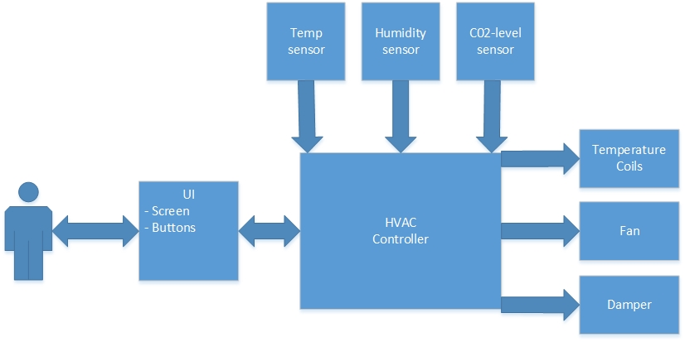

Figure2: System Overview

# Operational scenarios

As Figure 2 shows, the user can communicate directly with the HVAC DDC and adjust the temperature and humidity as they wish. The system will also get the outside temperature from the internet, and adjust the indoor temperature to make it more efficient. When it comes to bigger rooms with more people inside managing the temperature, the system will find the most popular settings among the ones entering, and find a smart way to set the temperature or humidity. If the user wants to get more fresh air, the system will first check the CO2 sensor and then act accordingly.

When it comes to the panel concept its similar to the mobile solution. The panel will be connected to the HVAC DDC just like the mobile solution is. Existing CO2 monitors will be replaced with the new panel, and the panel will communicate with the HVAC system just like the mobile system does.  
Both concepts have one thing in common, and that is that the user can influence the indoor environment.

# Analysis of the proposed system

Different improvements and disadvantages of the proposed system are covered in this part of the document.

## Improvements

* Possibility to customize their private environment by using remote access.
* The proposed system gives the user the choice to customize the automated system to their own need

## Disadvantages

* Resource cost because of higher amount of controller devices
* Need of higher security of data because of the transmission of sensor and control data over internet
* Higher probability of misuse of environment settings